Honors Study/Travel Program
Summer 2012

Excavations at Tell es-Safi Gath

Archaeology Fieldwork (SOCI 1212H)

Biblical History and Archaeology (BIB 4935H)

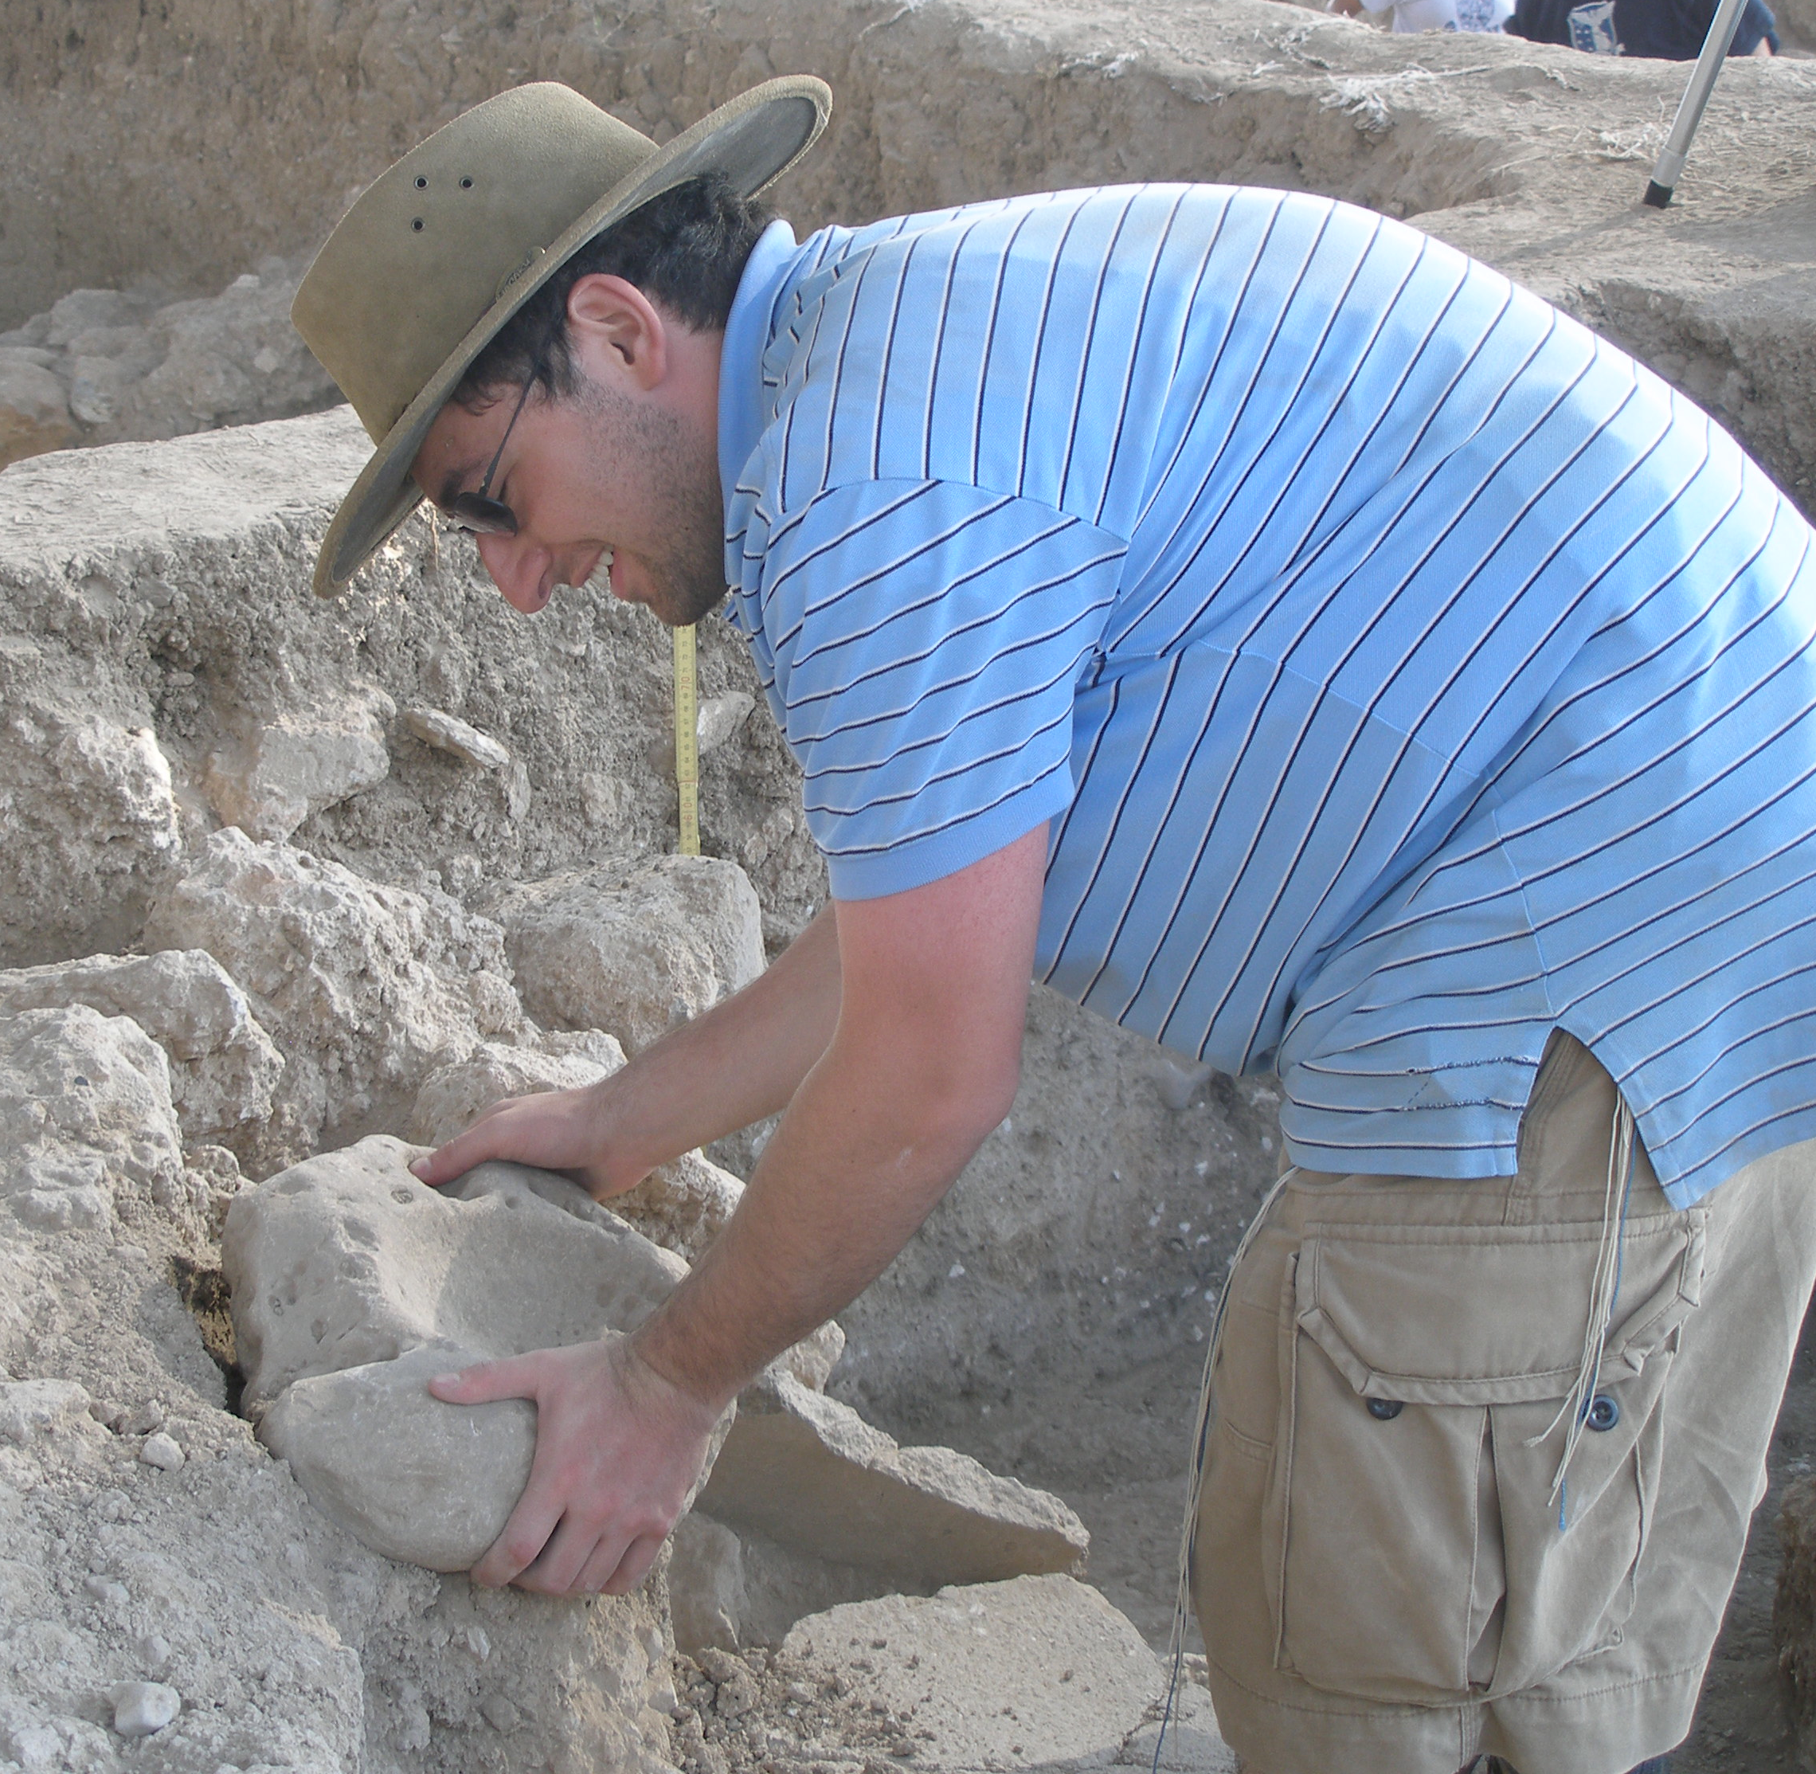

Duration: June 18-July 20 (New York, June 18-28; Israel, July 1-20)
Cost: $3,000 + airfare (includes room and board in Israel and tuition for 3 credits)
Open to both YC and SCW students; honors and non-honors students welcome

Course Description
This course combines biblical history and archaeology with actual archaeological fieldwork. During the first two weeks, students will learn through lectures—3 hours/day—readings, and individual research about the history and archaeology of the Land of Israel from the time of the Judges to the end of the First Temple (Iron Age I-II; 1200-586 BCE). Subsequently, students will travel to Israel to participate in archaeological excavations. They will continue their learning in formal evening lectures, but the primary goal here is to gain practical experience in the recovery and analysis of the material remains, and learn how these finds are used by archaeologists and historians to gain new insight into biblical history.

Contact: Dr. Jill Katz, jckatz@yu.edu
3 credits

