Welcome Dr. Peter Franz and Dr. Sarah Bloch-Elkouby to Ferkauf’s Adult Clinical PsyD Program’s Core Faculty!
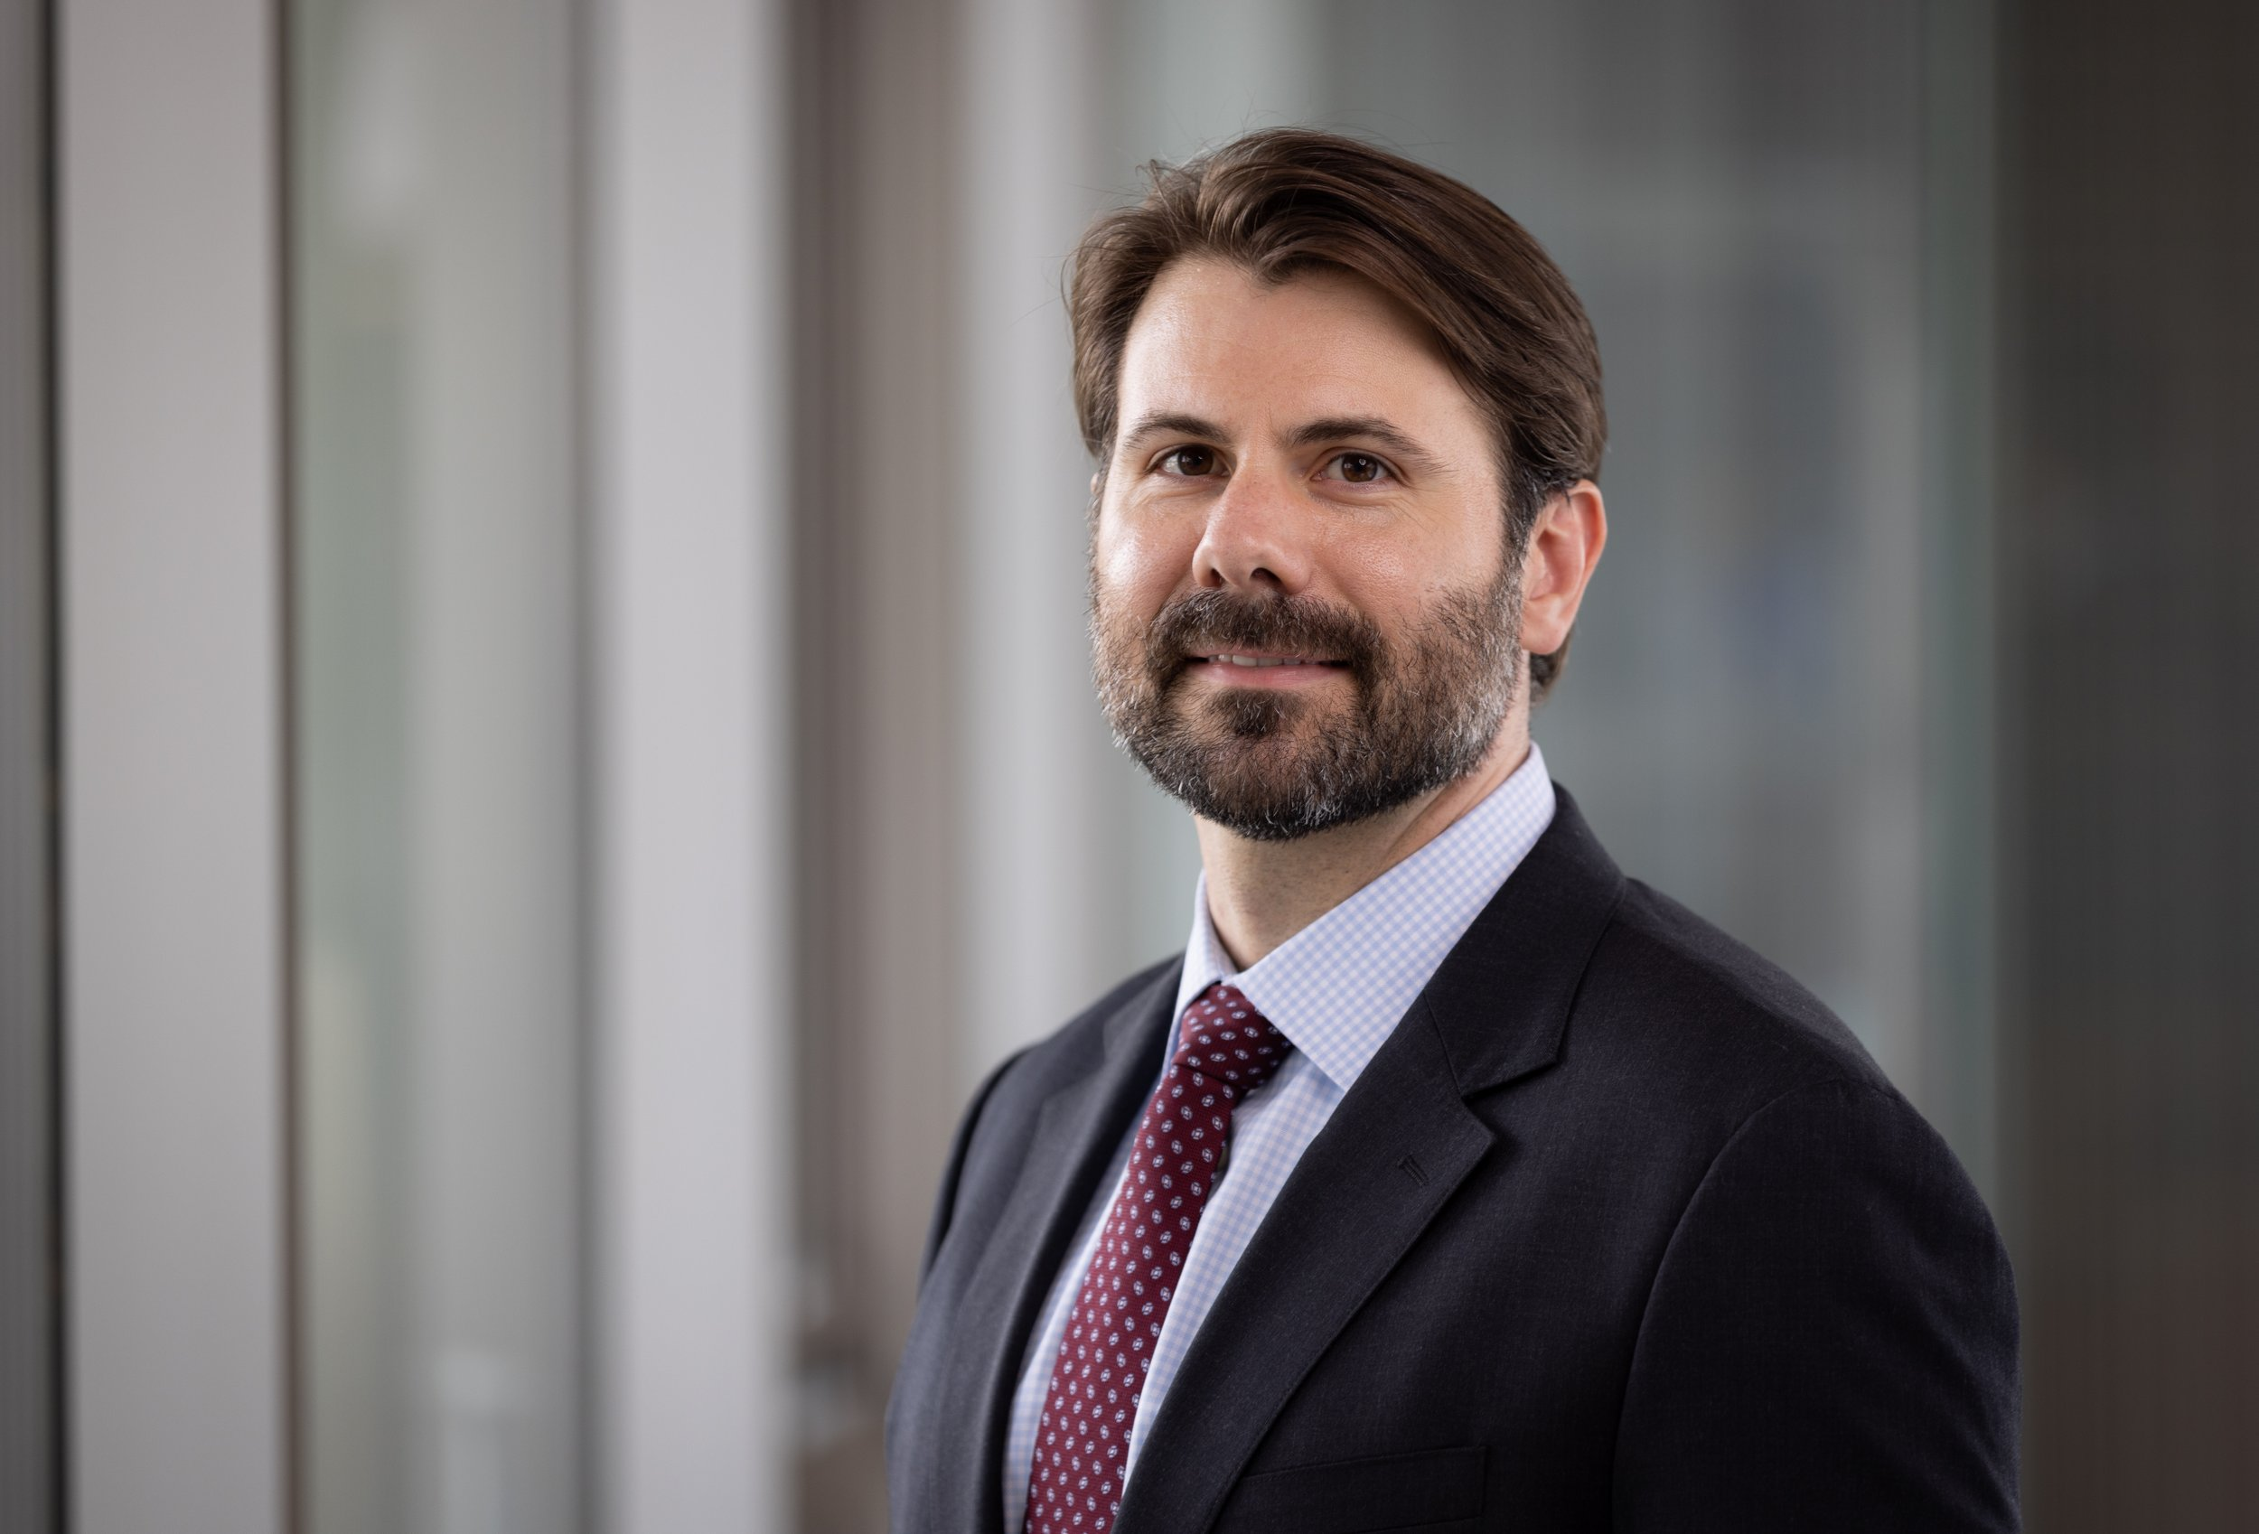
Peter J. Franz, Ph.D (he/him/his)
Dr. Franz’s program of research is focused on better understanding and ultimately preventing self-injurious thoughts and behavior (SITB). His research program has two main arms. In the first, he uses laboratory experiments and ecological assessments to understand why feeling bad (i.e., negative emotions) leads some people to want to hurt themselves. In the second arm, he is developing accessible digital interventions to prevent suicide using online resources like social media. Pete serves as a consultant to two internet social media platforms where he conducts research. Pete received his B.S. from Cornell University, his Ph.D. in Clinical Psychology from Harvard University, and he completed his Clinical Internship at Columbia University Irving Medical Center.

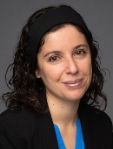
Sarah Bloch-Elkouby, Ph.D
Dr. Bloch-Elkouby’s lab focuses on the therapeutic alliance among culturally diverse dyads, enhancing suicide risk assessment and treatment with empirically validated models of suicide and alliance-focused principles, and clinicians’ training using artificial intelligence. On the clinical side, she supervises the psychology program in the adult and geriatric acute inpatient unit and provides services and supervision for patients at high risk for suicide in the outpatient department. She is a co-investigator at the Brief Psychotherapy Research Program and the Mount Sinai Suicide Research Lab. Her research is funded by the American Foundation for the Prevention of Suicide (AFSP), the American Psychoanalytic Association (APSAA), the American Psychological Association (APA), and the Society for Psychotherapy Research (SPR).

