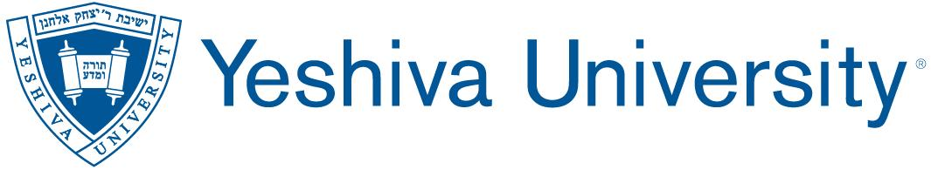
LEARNING ACTIVITY ASSESSMENT REPORT SPRING 2021
Due June 1, 2021
- Please attach or past below your program’s mission statement, and goals and objectives.

- Please attach or paste below your program’s most current curriculum map.

- Which two program objectives did you directly assess this semester, and in connection with which courses/learning experiences?

- In what two ways were each of those two objectives assessed, and how was each assessment scored (please attach any rubrics or checklists used)?

- What were the results of each of those assessments, and what do the results indicate about the extent to which each objective was achieved?

- Based on the results, what might your program change or do differently to improve student learning and instruction? (Please note: If your program was unable to meet during the Spring 2021 semester to discuss use of the assessment results, please indicate what plans you are making to do so during the Fall 2021 semester).

- With whom are you going to share the assessment results, and in what manner?

- Which two objectives do you plan to assess next semester, in connection with which courses/learning experiences, and with which assessment measures?

- Which two objectives do you plan to assess in each of the next four consecutive semesters, and in connection with which courses/learning experiences?

- What changes, if any, would you like to make to your program assessment process in the future? (Please note: If your program was unable to meet during the Spring 2021 semester to discuss use of the assessment results, please indicate what plans you are making to do so during the Fall 2021 semester).

