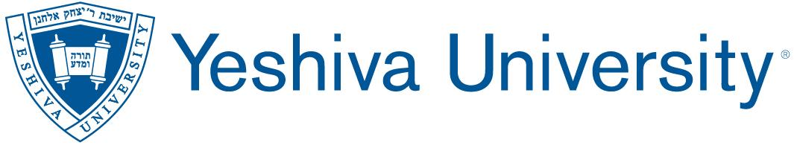
Stern General Education Requirement Supplement
Spring 2020
DUE: At the end of each academic semester
LEARNING ACTIVITY ASSESSMENT REPORT
Semester : Fall 2019
College/School: Stern College
Department:
Program: General Edcuation
Contact Name:
Email:
Phone:
I. Mission Statement:

The aim of the general education requirement at Stern College for Women is to provide students with the finest contemporary academic education consistent with the liberal arts tradition, and in accordance with both Stern's and Yeshiva University's missions. The general education requirement engages students in a rigorous curriculum encompassing both general and Jewish studies. By exposing Stern students to a range of disciplinary areas, the general education requirement seeks to foster the following inter-disciplinary student learning goals: critical thinking, communication skills, quantitative and scientific reasoning, personal development, and global awareness.

II. Stern General Education Goals and Objectives:

- Critical Thinking: Students will critically evaluate texts, problems, arguments, and evidence. Students will demonstrate attainment of this goal by being able to:

  - interpret and assess primary and secondary sources within a discipline

  - evaluate competing arguments for logical cogency and evidentiary quality

  - critically analyze their own assumptions and views in light of the perspectives of others

- Communication: Students will effectively communicate their learned knowledge and own perspectives on various subjects, both orally and in writing. Students will demonstrate attainment of this goal by being able to:

  - clearly analyze an issue or problem orally and/or in writing

  - present relevant information and ideas in an organized fashion orally and/or in writing

  - develop and express their own informed perspectives on various topics within a discipline in various modalities

- Quantitative and Scientific Reasoning: Students will be able to apply quantitative and scientific reasoning to identify, analyze, and/or solve problems, create deductive arguments, and make informed decisions. In addition students will be able to communicate numerical data in an understandable way to a variety of audiences. Students will demonstrate attainment of this goal by being able to:

  - follow the steps of the scientific method to identify and solve problems

  - apply mathematical and scientific concepts to analyze problems

  - collect, organize, analyze numerical data pertaining to a particular problem or question

  - communicate numerical data in an understandable way to a variety of audiences

- Personal Development: Students will possess the desire and skills to be life-long learners. Students will demonstrate attainment of this goal by:

  - demonstrate the knowledge, skills, and desire to independently gather and evaluate multiple sources of information relevant to their learning goals

  - taking ownership their own learning experiences, including setting challenging but realistic learning goals, self-monitoring their learning and attainment of learning goals, evaluating their performance and using this information as feedback to inform their future learning pursuits.

- Global Awareness: Students will be globally aware, socially responsible, and contribute to the community at large. Students will demonstrate attainment of this goal by being able to:
  - understand and appreciate political, economic, and cultural diversity

  - be socially responsible citizens who are sensitive to global and local challenges

  - Students will be able to recognize the importance and value of contributing to their community at large

III. Please compete the following questions:

- Which two general education program objectives did you directly assess this semester, and in connection with which courses/learning experiences?

- In what two ways were each of those two objectives assessed, and how was each assessment scored (please attach any rubrics or checklists used)?

- What were the results of each of those assessments, and what do the results indicate about the extent to which each objective was achieved?

- Based on the results, what might your program change or do differently to improve student learning and instruction? (Please note: If your program was unable to meet during the Spring 2020 semester to discuss use of the assessment results, please indicate what plans you are making to do so during the Fall 2020 semester).

- With whom are you going to share the assessment results, and in what manner?

- Which two general education objectives do you plan to assess next semester, in connection with which courses/learning experiences, and with which assessment measures?

- Which two general education objectives do you plan to assess in each of the next four consecutive semesters, and in connection with which courses/learning experiences?

- What changes, if any, would you like to make to your program assessment process in the future? (Please note: If your program was unable to meet during the Spring 2020 semester to discuss use of the assessment results, please indicate what plans you are making to do so during the Fall 2020 semester).

