September 2026
Please share with your faculty:
Writing Effective Program-Level Student Learning Objectives

Student learning objectives are statements that describe the specific skills that students should exhibit as a result of a learning experience. Student learning objectives should be reflective of the overarching student learning goal. Unlike student learning goals which are stated at the conceptual level, student learning objectives should be directly measurable. They are the specific measurable indicators of the larger overarching goal. Effective student learning objectives should be:
- Simply stated
- Student-centered
- Specific and relevant to one goal
- Measurable
- Attainable

It is recommended to state objectives as “students will be able to…” and to use action verbs associated with different categories in Bloom’s taxonomies (see table below)

Action Verbs Associated with Bloom et al.’s Taxonomy of Cognitive Processes

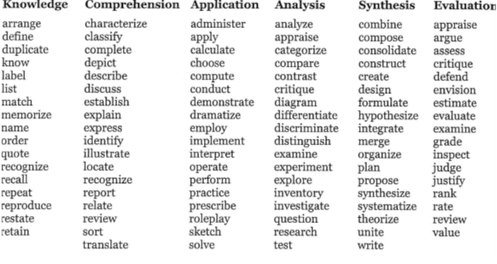

Please use the following checklist to ensure effective wording of objectives:
- Is the objective clearly and simply stated?
- Is the objective written using an action verb?
- Does the objective specify observable behaviors that are measurable?
- Is it possible to collect accurate and reliable data pertaining to the objective?
- Is the objective stated so that more than one measurement method can be used to assess it?
- Is it student-centered vs. teacher-oriented? (e.g., students will be able to evaluate vs. students’ will evaluate)

Example: of student learning objectives pertaining to a psychology program-level goal
- Goal: Psychology students will be able to apply psychological theories to real world contexts

- Objectives:
- Students will be able to choose relevant theories for examining a specific psychological issue

- Students will be able to demonstrate using theories to make informed recommendations pertaining to psychology-related issues and topics

References:

Brandeis University. (n.d.). Learning objectives. https://www.brandeis.edu/teaching/online-guides/learning-objectives/index.html

University of Connecticut Center for Excellence in Teaching and Learning. (n.d.). Aligning assessments to course objectives. https://cetl.uconn.edu/resources/teaching-and-learning-assessment/teaching-and-learning-assessment-overview/assessment-design/aligning-to-course-objectives/

Yeshiva University. (n.d.). YU program/major assessment template: Mission, goals, objectives & curriculum map [Template].

Check out: Yale University Poorvu Center for Teaching and Learning. (n.d.). Writing learning goals, objectives and outcomes. https://poorvucenter.yale.edu/teaching/teaching-resource-library/writing-learning-goals-objectives-and-outcomes

Reminder: Please feel free to reach out if you have any questions about your upcoming assessment plans.

Rachel.Ebner@yu.edu

Table from rom Brandeis University’s Assessment website. Retrieved November 8, 2013 from http://www.brandeis.edu/assessment/learning_goals/Learning_outcomes_worksheet.pdf

