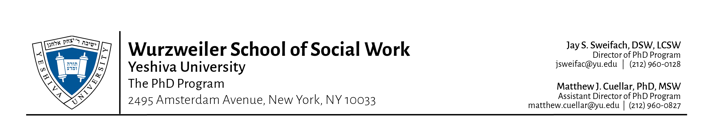
Ph.D. SPRING 2018 MONTHLY CALENDAR

 | January 2018
Sun | Mon | Tue | Wed | Thu | Fri | Sat
 | 1  New Year’s Day | 2 | 3 | 4 | 5 | 6
7 | 8  All Fall 2017 Incomplete grades due! | 9 | 10 | 11 | 12 | 13
14 | 15  Martin Luther King Day | 16 | 17 | 18 | 19 | 20
21 | 22 | 23 | 24  Orientation & Registration  (Incoming students only) | 25  THURSDAY #1 | 26 | 27
28 | 29 | 30 | 31  WEDNESDAY #1 | Notes:

 | February 2018
Sun | Mon | Tue | Wed | Thu | Fri | Sat
 |  |  |  | 1  THURSDAY #2 | 2 | 3
4 | 5  LAST DAY TO ADD  A COURSE | 6 | 7  WEDNESDAY #2  LAST DAY TO WITHDRAW /DROP A COURSE - 100% TUITION REFUND | 8  THURSDAY #3 | 9 | 10
11 | 12 | 13 | 14  WEDNESDAY #3  LAST DAY TO WITHDRAW /DROP A COURSE -75% TUITION REFUND | 15  THURSDAY #4 | 16  Chinese New Year | 17
18 | 19  President’s Day | 20 | 21  WEDNESDAY #4  LAST DAY TO WITHDRAW /DROP A COURSE - 50% TUITION | 22  THURSDAY #5 | 23 | 24
25 | 26 | 27 | 28  WEDNESDAY #5  LAST DAY TO W/D/DROP A COURSE - 25% TUITION REFUND. AFTER 2/28/18. NO REFUND FOR W/DRAWAL FROM WSSW | Notes:

 | March 2018
Sun | Mon | Tue | Wed | Thu | Fri | Sat
 |  |  |  | 1  PURIM  No classes | 2 | 3
4 | 5 | 6 | 7  WEDNESDAY #6 | 8  THURSDAY #6 | 9 | 10
11  Daylight Savings Time | 12 | 13 | 14  WEDNESDAY #7 | 15  THURSDAY #7 | 16 | 17
18 | 19  OPENS 12:01 AM  Summer On-line Registration opens. | 20 | 21  WEDNESDAY #8 | 22  THURSDAY #8 | 23 | 24
25 | 26 | 27 | 28  WEDNESDAY #9 | 29  THURSDAY #9 | 30  EVE OF PASSOVER  SPRING BREAK | 31  PASSOVER  SPRING BREAK

 | April 2018
Sun | Mon | Tue | Wed | Thu | Fri | Sat
1  PASSOVER  SPRING BREAK  Easter Sunday | 2  PASSOVER  SPRING BREAK | 3  PASSOVER  SPRING BREAK | 4  PASSOVER  SPRING BREAK | 5  PASSOVER  SPRING BREAK | 6  PASSOVER  SPRING BREAK | 7  PASSOVER  SPRING BREAK
8 | 9 | 10 | 11  WEDNESDAY #10 | 12  THURSDAY #10 | 13 | 14
15 | 16  Opens 12:01 AM  Fall 2018 On-line Registration opens. | 17 | 18  WEDNESDAY #11 | 19  THURSDAY #11 | 20 | 21
22 | 23 | 24 | 25  WEDNESDAY #12 | 26  THURSDAY #12 | 27 | 28
29 | 30 | Notes:

 | May 2018
Sun | Mon | Tue | Wed | Thu | Fri | Sat
 |  | 1 | 2  WEDNESDAY #13 | 3  THURSDAY #13 | 4 | 5
6 | 7  Comprehensive  Exam | 8 | 9  WEDNESDAY #14 | 10  THURSDAY #14 | 11 | 12
13  MOTHER’S DAY | 14 | 15  GRADUATION | 16 | 17 | 18 | 19
20  SHAVUOT | 21  SHAVUOT | 22 | 23 | 24 | 25 | 26
27 | 28  Memorial Day | 29 | 30 | 31 | Notes:  Official degree conferral date 5/31/2018

