YU Program/Major Assessment Template:
Mission, Goals, Objectives & Curriculum Map

College/School Name: Sy Syms School of Business
Department/Program Name: Mitzner Masters of Science in Real Estate
Contact Name: Andreas D. Christopoulos, Ph.D., Founding Director
Email: andreas.christopoulos@yu.edu
Phone: NA
I. Department/Program Mission Statement
The mission of the Mitzner Masters of Science in Real Estate (MSRE) at the Sy Syms School of Business of Yeshiva University is to prepare students for employment in various real estate related business enterprises and to establish Yeshiva University as a center for excellence in the discipline of real estate. The purpose of the program is to develop students’ knowledge of many aspects of real estate as a unique financial enterprise. Among the facets of real estate explored in the program are construction, management, design, leasing, risk/reward assessment, and financing and investment profiles of real estate debt and equity markets.
II. Department/Program Student Learning Goals
MSRE students will be able to:
- Know key concepts and central issues pertinent to the field of commercial and residential real estate finance, market assessment, and site analysis.
- Analyze investment and lending opportunities in real estate related debt and equity securities, whole loans, properties, and land using professional analytical technology and data.
- Evaluate buildings as ‘hard assets’ with a dynamic role in local business formation and promulgating residential activity and vice versa.
- Consider alternative uses for sites dynamically responding to changes in financing costs and changes in demand and use of space.
- Create and defend their own analyses of buildings and financing opportunities with real time projects in the current marketplace.

III. Department/Program Student Learning Objectives:
- Students will be able to differentiate the strengths and weaknesses of property type mix (industrial, apartment, office, hotel, retail and mixed use) and assess the relative value of properties on a standalone basis, and within portfolios of properties or mixed asset classes (buildings, debt instruments, REITs and real estate derivatives).
- Students will be able to employ advanced valuation techniques and statistical assessments considering default, prepayment, liquidity, and rate risks to investments and weigh statistically driven objective measures against subjective measures in evaluation investments and trends in the real estate market.
- Students will be able to perform statistical analyses and to read and report on market assessments from third party professional and academic sources.
- Students will be able to perform complex mixed-use proforma analyses of commercial properties using Excel, ARGUS and the statistical package R.
- Students will be able to engage directly with data sets in performing market analyses as a component of investment analysis.
- Students will be able to relate location planning considerations at the state, local and federal level to economic feasibility of new construction opportunities.
- Students will be able to demonstrate their ability to compare and contrast investment opportunities tactically with respect to changing market conditions reflective of existing building stock, new construction being brought online and overall costs of borrowing.
- Students will be able to envision a new development opportunity and/or a repurposing opportunity in real estate.
- Students will be able to demonstrate begin to end professional assessment and presentation of original work on a complex property and/or financing project with written, oral and analytical components.
- Students will be able to demonstrate burgeoning professional judgement and skill across core competencies in real estate and shall consider ‘out of the box’ thinking on highest and best use for real estate and concomitant risk/reward analysis from the perspective of the borrower, lender and sponsor/investor.

Directions: Complete the following table by listing each department/program goal in the left column. For each Program goal list 2-3 objectives in the right column.
Department/Program Goal | Objectives
1. Know key concepts and central issues pertinent to the field of commercial and residential real estate finance, market assessment, and site analysis. | a. Students will be able to differentiate the strengths and weaknesses of property type mix (industrial, apartment, office, hotel, retail and mixed use) and assess the relative value of properties on a standalone basis, and within portfolios of properties or mixed asset classes (buildings, debt instruments, REITs and real estate derivatives).
 | b. Students will be able to employ advanced valuation techniques and statistical assessments considering default, prepayment, liquidity, and rate risks to investments and weigh statistically driven objective measures against subjective measures in evaluation investments and trends in the real estate market.
2. Analyze investment and lending opportunities using professional analytical technology. | a. Students will be able to perform complex mixed-use proforma analyses of commercial properties using Excel, ARGUS and the statistical package R.
 | b. Students will be able to perform statistical analyses and to read and report on market assessments from third party professional and academic sources.
3. Evaluate buildings as ‘hard assets’ with a dynamic role in local business formation and promulgating residential activity and vice versa. | a. Students will be able to relate location planning considerations at the state, local and federal level to economic feasibility of new construction opportunities.
 | b. Students will be able to demonstrate their ability to compare and contrast investment opportunities tactically with respect to changing market conditions reflective of existing building stock, new construction being brought online and overall costs of borrowing.
4. Consider alternative uses for sites dynamically responding to changes in financing costs and changes in demand and use of space. | a. Students will be able to envision a new development opportunity and/or a repurposing opportunity in real estate.
 | b. Students will be able to engage directly with data sets in performing market analyses as a component of investment analysis.
5. Create and defend their own analyses of buildings and financing opportunities with real time projects in the current marketplace | a. Students will be able to demonstrate begin to end professional assessment and presentation of original work on a complex property and/or financing project with written, oral and analytical components.
 | b. Students will be able to demonstrate burgeoning professional judgement and skill across core competencies in real estate and shall consider ‘out of the box’ thinking on highest and best use for real estate and concomitant risk/reward analysis from the perspective of the borrower, lender and sponsor/investor.

IV. Curriculum Mapping
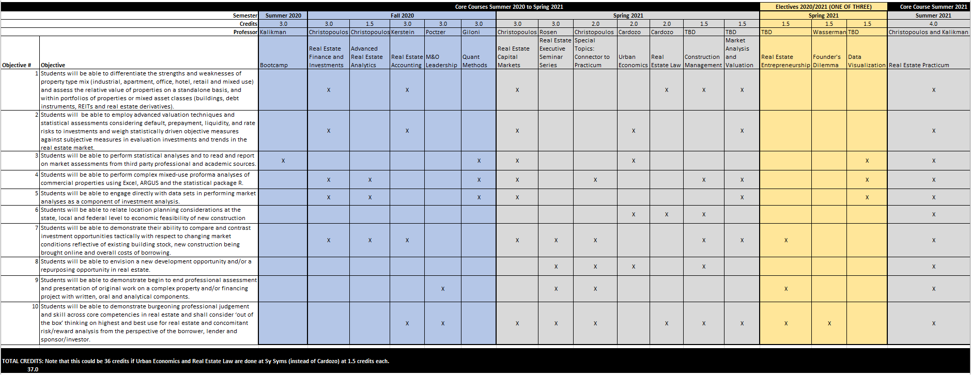

Table adapted from the OAPA handbook program based assessment and review, University of Massachusetts (Amherst). Retrieved Nov. 8, 2013 from http://www.umass.edu/oapa/oapa/publications/online_handbooks/program_based.pdf

