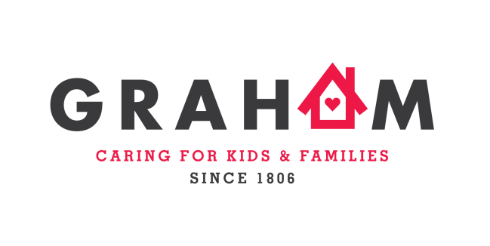

CAREER OPPORTUNITIES
In full partnership with families & communities, Graham Windham strives to make a life-altering difference to children, youth and families affected by abuse, neglect and delinquency. Graham Windham’s overall mission is to ensure that every child we serve has a strong, loving, permanent family, and the opportunities and preparation to succeed in school and life.
We are presently seeking experienced Case Planners, Therapists, Supervisors and Wellness Technician.

Family Advocate:
Graham is hiring 5 Family Advocates who will support parents with children in foster care to understand and navigate the foster care system, make decisions for their families, remain hopeful, and address family challenges so that they can accomplish their goal of reunification. The focus of this job is building connections with parents and working collaboratively with case planners. Each Parent Advocate will be assigned to a case planning unit and will support parents and bring their experience to the foster care agency decision-making process so that children are more likely to quickly and safely return home. The Advocates will be part of the Parents Supporting Parents initiative recently launched by the NYC Administration for Children’s Services (ACS), in conjunction with Rise, a parent-led NYC advocacy organization, and other important child welfare stakeholders. All Advocates will receive training and support through Rise.
This initiative is built upon the premise that Advocates with their own personal prior lived experience of the child welfare system will be effective in informing and supporting parents with children in foster care, and help to improve outcomes for children and families.
High school diploma/General Equivalency Diploma (GED), preferred; Experience with the child welfare system
CASAC
The CASAC will provide assessments of client substance abuse disorders and use an eclectic approach of engagement and service delivery. The CASAC will also support the case planning staff in the implementation of case specific goals of families; will be part of a multi-method program and has a consistent strong approach to partnering with families to promote the safety and wellbeing of all children; ensure that our families and staff have access to high-quality resources to meet their needs.
Provide case management, substance abuse counseling, and advocacy services. Participate as a member of an interdisciplinary treatment team to facilitate the client recovery and rehabilitation processes Provides consultation to case planners regarding families who struggle with substance abuse Participate in all Clinical Diagnostic Team (CDT) meetings. Conducts intakes including psychosocial history, makes clinical assessment and designs individual treatment plans
CASAC certification with MSW and a minimum of three years of experience working with adolescents/children and parents/caretakers that abuse substances is preferred, or CASAC certification with a BSW and minimum of five years of experience working with adolescents/children and parents/caretakers that abuse substances

Director of Mental Health
Our community-based clinic provides quality mental health services to children and youth, and their caregivers. Our services address a range of mental-health related issues including behaviors that interfere with school success (inattention, hyperactivity, aggression, etc.) as well as child and adolescent depression, anxiety and ADHD. In addition to addressing and resolving behavior, a primary goal of our licensed clinical staff is to help our children, youth and families address and heal the trauma associated with child and youth maltreatment including physical and sexual abuse.
The Director of Mental Health is responsible for the direct oversight and all aspects of program services for the Art 31 OMH & SBMH clinic. The Director works in close collaboration with Graham’s Foster Care, Preventive and Behavioral Health management staff, birth parents, foster parents and external providers. They are directly responsible for the compliance of OMH/SBMH record standards and all aspects of their supervisee’s roles and responsibilities.

LMHC/LCSW/Ph.D. A minimum of 5 years postgraduate experience and at least 5 years of supervisory experience.

**Please have interested job seekers visit http://www.graham-windham.org to apply!!!
For internal staff, additional information is available on our Sharepoint Home Page

