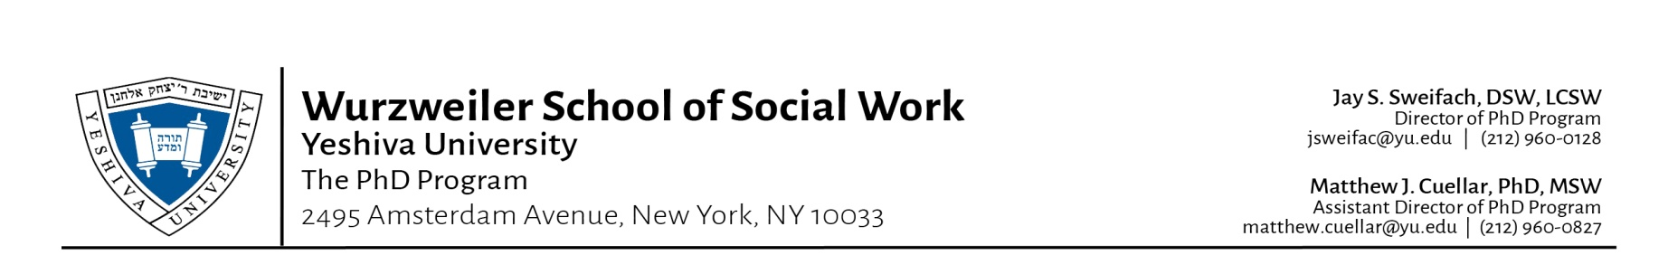
YESHIVA UNIVERSITY
WURZWEILER SCHOOL OF SOCIAL WORK
PHD PROGRAM
ACADEMIC CALENDAR SPRING 2018
Monday January 1 New Year’s Day (School Closed)
Monday January 8 All Fall 2017 Incomplete Grades Due
Monday January 15 Martin Luther King, Jr. Day (School closed)
Sunday January 21 Last day for Online Registration
Wednesday January 24 Orientation/Registration Incoming Students
Thursday January 25 First Thursday Class
Wednesday January 31 First Wednesday Class
Monday February 5 Last Day to add a course
Wednesday February 7 Last day to withdraw and drop a course with 100% tuition refund
Wednesday February 14 Last day to withdraw and drop a course with 75% tuition refund
Wednesday February 21 Last Day to withdraw and drop a course and withdraw with 50% tuition refund
Wednesday February 28 Last Day to drop a course without a ‘W’ appearing on transcript. Also, last day to drop a course /withdraw from school with 25% tuition refund. After February 28th no refund for withdrawal from WSSW
Thursday March 1 Purim (No classes)
Monday March 19 Summer Program 2018 Online Registration Opens
PASSOVER SPRING BREAK – MARCH 30th – APRIL 7th - NO CLASSES
Sunday April 1 No Classes (Easter Sunday)
Sunday April 8 Classes Resume
Wednesday April 11 Deadline to file for May 2018 Graduation
Monday April 16 Fall 2018 Online Registration Opens
Monday May 7 Comprehensive Exam
Wednesday May 9 Last Wednesday class
Thursday May 10 Last Thursday class
Monday May 14 All Spring 2018 Grades Due
Tuesday May 15 WURZWEILER SCHOOL OF SOCIAL WORK GRADUATION!
Tuesday May 29 All spring 2018 Incomplete Grades Due
Wednesday May 31 OFFICIAL DEGREE CONFERRAL DATE FOR GRADUATES

