Please share with your faculty: The importance of aligning student learning objectives, instructional methods, and methods of assessment.
As you plan your Fall 2018 courses, it is important to keep in mind the importance of aligning student learning objectives, instructional strategies, and assessment methods. The purpose of assessment is to gather evidence about the extent to which student learning objectives have been obtained. In order to determine if student learning objectives have been met, the assessment must be a valid and reliable measure of the objective. For example, if the objective is for students to be able to clearly organize their ideas in written form, then a multiple choice or a true of false test would not be sufficient assessment, because that type of an assessment measures students’ ability to remember information, not create content. In addition, the instructional activities must also provide students with plenty of opportunities to learn and practice the targeted objective. Blooms Taxonomy, which classifies human cognition into hierarchical levels, can be a useful reference tool when making sure that student learning objectives, instructional activities, and assessment methods are aligned. The chart pasted below provides some examples of instructional activities that align with the different educational objectives stated in Bloom’s Taxonomy.

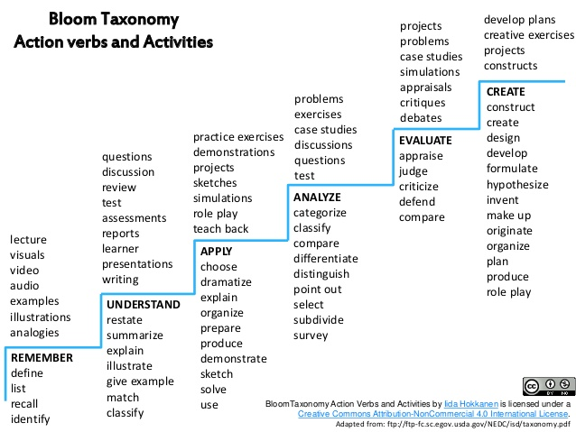

Source: https://www.slideshare.net/IidaHokkanen/bloom-taxonomy-action-verbs-and-activities

In addition, you can use the chart below to map student learning objectives onto instructional strategies and assessment methods in order to help ensure that all three of these components are aligned.

Student Learning Objectives | Instructional Strategies | Assessment Methods

Please share your program’s examples of creating effective assessments! Please email to me examples of how your program designs effective assessments, I will feature those examples on YU’s Learning Assessment Website.

Check out!: Why should assessments, learning objectives, and instructional strategies be aligned? Carnegie Mellon University, Eberly Center. Retrieved July 24, 2018 from https://www.cmu.edu/teaching/assessment/basics/alignment.html

Fall 2018 Assessment Plans: Please be sure to contact faculty in your program that will be conducting Fall 2018 assessment activities so that they can plan accordingly prior to the start of the semester. If you would like to meet to discuss any aspect of your Fall 2018 assessment plans, please contact me.

