Introduction:
Time of survey: December 2020 – February 2021.
Number of participants: 171 (Participants included only those who provided their full salary information.)
Gender: Female: 85; Male: 86
Age: Rank:
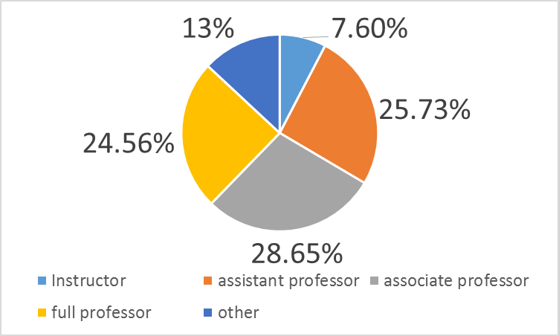
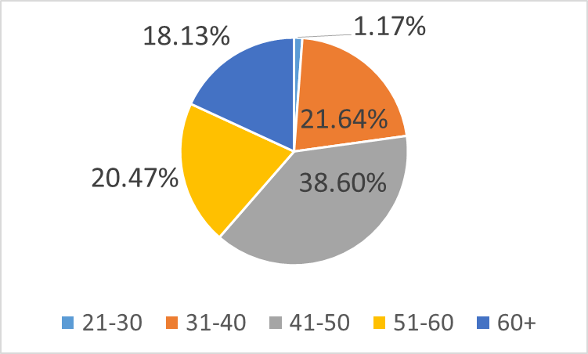

School:
Rank | Total faculty | % of faculty
Instructor | 13 | 7.6
Assistant | 44 | 25.73
Associate | 49 | 28.65
Professor | 42 | 24.56
Other | 23 | 13.45
All | 171 | 100

School | %
YC | 21.64
SCW/STERN | 21.05
FERKAUF | 11.11
SYMS | 10.53
CARDOZO | 8.19
WURZWEILLER | 7.02
KATZ | 5.26
OTHER | 5.26
REVEL | 2.92
REITS | 2.92
NO ANSWER | 2.92
AZRIELLI | 1.17

Results:

Rank | YU salary
Instructor | $59,115
Assistant | $102,558
Associate | $95927
Professor | $137,781
Other | $84,996
All | $96,075

Table 1: Average salaries by rank.

Rank | Men | Women
Instructor | $69,600 | $52,562
Assistant | $111,712 | $95,601
Associate | $97,591 | $94,454
Professor | $140,905 | $129,969

Table 2 Average YU salaries by rank and gender.

 | Men |  |  | Women
Rank | # | Faculty % | # | Faculty % | M:F ratio
Instructor | 5 | 3% | 8 | 5% | 1:1.6
Assistant | 19 | 12.5% | 25 | 17% | 1:1.3
Associate | 23 | 15% | 26 | 17% | 1:1.1
Professor | 30 | 20% | 12 | 8% | 2.5:1
 | 77 | 50.5% | 74 | 47% | 1.04:1

Table 3: Distribution of faculty by rank and gender

Length of service | Men | Women | Overall
<5 | $115,395 | $95,587 | $105,491
5-10 | $123,416 | $95,128 | $109,272
>10 | $108,959 | $93,743 | $101,351

Table 4: Average salaries by gender and length of service.

